Growth curve protocol for Chlorella vulgaris and Synechococcus elongatus PCC7942

Description
In order to investigate the optimal time to co-culture our modified E.coli and Chlorella vulgaris, evaluate growth of Chlorella vulgaris before Nile Red staining for oil determination in microalgal cells, we will measure the OD value at 680nm by using the spectrophotometer and analyze the growth curve in R.
However, we encountered some difficulties such as irregular measurement time and personal errors. Thus, we decided to search for better measurement method. Later, we borrowed a photo-bioreactor from Professor Ya Tang Yang, Department of Electrical Engineering, National Tsing Hua University, and used it to measure OD value for more precise bacterial growth curves.

Manual Measurement
The following words are the instruction of how we measured the OD value of two kinds of microalgae manually.

Materials
- 1 liter of BG-11
- Axenic culture of Chlorella vulgaris and Synechococcus elongatus PCC7942 in both sterile (autoclaved) 250 mL Erlenmeyer flasks/ 25 mL Petri Dish.
- Spectrophotometer.

Preparation
- Re-heat BG-11 medium from the refrigerator in heat bath, and take both plates which we cultured Chlorella vulgaris and Synechococcus elongatus PCC7942 from the incubator to measure the OD value.
- All procedures were conducted in a laminar flow hood.
- For each measurement, take 150 μL of BG-11 medium, Chlorella vulgaris 10x dilutions with BG-11 medium, and Synechococcus elongatus PCC7942 10x dilutions with BG-11 medium onto 96-well microplate.
- Conduct the measurement among the three replicates.

Measurement
- Before measurement, pipette the solution of Chlorella vulgaris and Synechococcus elongatus PCC7942 in the wells to ensure they are properly mixed.
- Measure the OD value at 680nm four times a day (preferably with at least 6 hours of difference between measurements) and repeat for 14 days.
- Record OD values and key the data in the spreadsheet to do statistics.
- After measuring, make sure all measurements remain at their respective temperatures and aerated.

Result
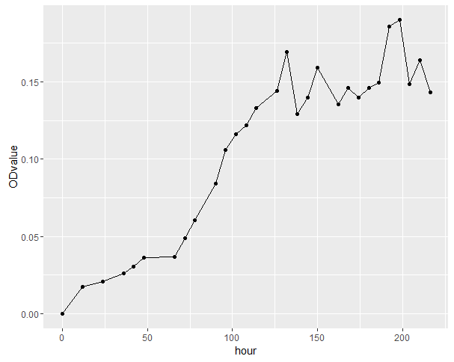
Figure 1
- The above line chart presents growth curve of Chlorella vulgaris. This measurement lasted more than 216 hours and it roughly meets our expectation.
- Although the later part of growth curve shows violent fluctuating range, it may be affected by environmental nitrogen metabolites from Chlorella vulgaris.
- The measurement result helps us determine lipid production of Chlorella vulgaris and the time we add NrtA-transformed E. coli into the medium to establish a co-culture system.

Note
- 10x dilutions of each sample is to prevent OD600nm measurements from Experimental distortion if going above 0.5.
- The reason of measuring the OD value at 680nm every six hours and repeat for 14 days is based on the papers we read.

Automatic Measurement
The following instructions describe how we measured the OD value of two kinds of microalgae via the photo-bioreactor and automatically.

Description
In the photo-bioreactor, there are four light-emitting diode sources and two photodetectors. Once calibrated, the device can cultivate microbial cells and record their growth expression without human intervention. We measure two kinds of microalgae during cell growth in same culture medium, BG-11.
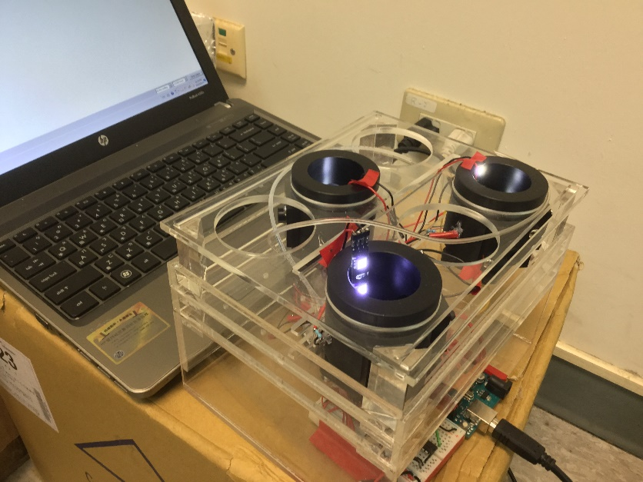
Figure 2
The photo-bioreactor was designed by Professor Yang. It was made with Arduino and some circuit components. Yang’s students also helped us assemble and teach us how to use this device. The photo-bioreactor itself can detect multiple units of organisms at same time, has pumps, fans, stir bars and some light bars. In Yang’s laboratory, we created a calibration curve for correcting and confirmed that there was a very high degree of correlation between voltage and OD value. This can be observed in the charts below.
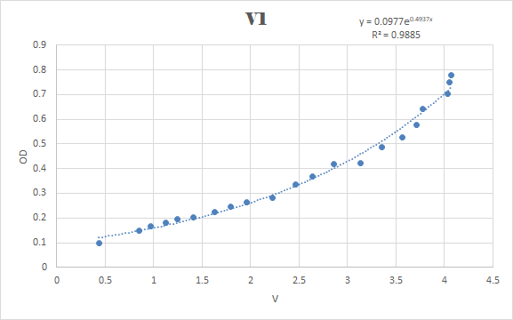
Figure 3
R-squared = 0.9885
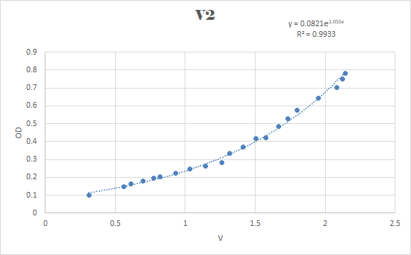
Figure 4
R-squared = 0.9933
Preparation
1. Reheat BG-11 medium from the refrigerator in heat bath, and take both petri dish which we cultured Chlorella vulgaris and Synechococcus elongatus PCC7942 from the incubator. All procedures were conducted in a laminar flow hood.
2. For each measurement, take 9 mL of BG-11 medium, Chlorella vulgaris 10x dilutions with BG-11 medium, and Synechococcus elongatus PCC7942 10x dilutions with BG-11 medium, into culture vial with a working volume of approximately 10 mL.
3. Continuous measurement in the dark state for eight to ten days.
4. Since Professor Yang and his students had set the measurement frequency once every minute, the photo-bioreactor would automatically upload the voltage value to the receiver, our lab computer.
5. After turning these data on Arduino interface from Text file to CSV file via Python, we insert the photo-voltage-absorbance conversion formula, recorded previously, on Excel and draw growth curves like following charts.
6. Repeat the above steps and compare results with simulation model.

Result

Figure 5
1. The above line chart presents growth curve of Chlorella vulgaris, under measurement near 10000 minutes made by the photo-bioreactor.
2. In comparison to the stimulation model we made, the result meets our expectation.
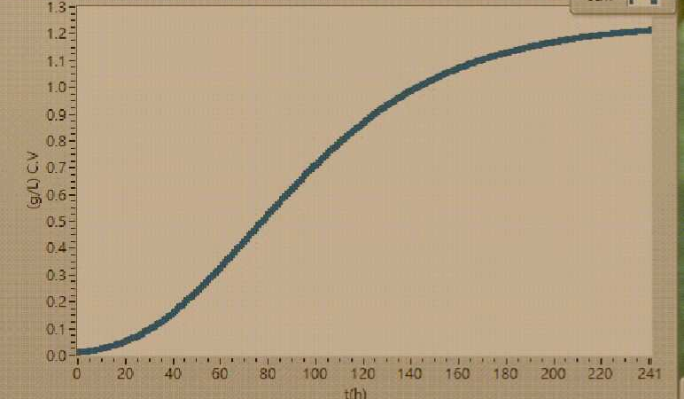
Figure 6
Resource
- An. Acad. Bras. Ciênc. (2013) Growth and biochemical composition of Chlorella vulgaris in different growth media. vol.85 no.4 Rio de Janeiro 2013 Epub Oct 11, 2013. doi: 10.1590/0001-3765201393312
- Wang H, Yang YT. (2017) Mini Photobioreactors for in Vivo Real-Time Characterization and Evolutionary Tuning of Bacterial Optogenetic Circuit. ACS Synth Biol. 2017 Sep 15;6(9):1793-1796. doi: 10.1021/acssynbio.7b00091
- Kuan, David (2013) Growth Optimization of Synechococcus elongatus PCC 7942 In Lab Flask and 2D Photobioreactor. University of British Columbia. 2013 Sep 3. doi: 10.14288/1.0074247

