Essential paper Summary:

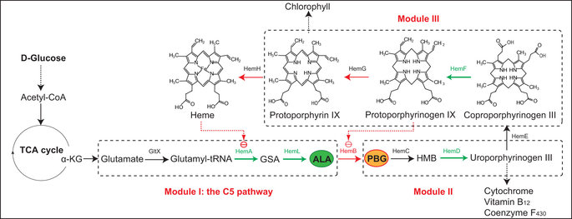
-From the graph, the haem groups are major regulators in the C5 pathway, Haem A Haem L, Haem D and Haem F in particular are linked to increasing ALA production. Whereas Hem B, HemG and Hem H diminished ALA production.
- Hem B is a key control node and might be feedback inhibited by the intermediate protoporphyrinogen IX
-C5 pathway results in the biosynthesis of ALA from glutamate.
-We need to find a way to remove glycine and succinate
-hemA17,18,19,20 (encodes glutamyl-tRNA reductase, Salmonella arizona) and hemL (encodes glutamate-1-semialdehyde aminotransferase, E. coli) in E. coli
-overexpression of rhtA (encodes a membrane protein for threonine and homoserine exporting, E. coli) and optimization of minimal medium composition and cultivation process also increases ALA.
-Need to know more about haem regulation methods
-Express genes using low-copy number vector pCDFDuet-1 inE. Coli
-In particular, up-regulation of hemB resulted in reduced biomass and glucose consumption which is likely due to the accumulation of the harmful intermediate porphobilinogen (PBG) and its derivatives12 – So possibly downregulate Haem B?
-Interestingly, overexpression of hemG resulted in more biomass coupled with a long lag phase which is likely due to its direct involvement in energy generation26 and the toxic intermediate protoporphyrin IX27.

-The results suggested that high-level overexpression of the upstream genes hemA^{s} and hemL as well as the downstream genehemF, and moderate overexpression of the downstream gene hemD are favorable to ALA accumulation.
-Furthermore, E. coli LAG with overexpression of hemG gave rise to a substantial increase in HemB activity (22.21 U mg⁻¹), which might be attributed to the direct activation by protoporphyrin IX or the weakened inhibition that caused by decreased protoporphyrinogen IX
-In this study, after investigation and identification of the four positive key genes towards ALA, the heme biosynthesis pathway was further optimized with two compatible plasmids pRSFDuet-1 (high-copy number) and pETDuet-1 (medium-copy number) according to previous results. As we expected, the production of ALA was significantly increased with an optimized combination of the increased flux towards ALA.
-One side, the results demonstrated that moderate expression of HemD is crucial to ALA accumulation since overexpression of HemD not only up-regulates the upstream genes but also draws more flux to downstream reactions from ALA.
-In comparison, the strategy of down-regulating HemB with overexpression of HemF was an alternative to improve ALA production.
- Use E. coliBL21 (DE3) was used as host for gene expression due to the T7 RNA polymerase. E. coli JM109 was used for DNA manipulations and plasmids construction.
-Luria-Bertani (LB) medium

