User Manual
- User interface
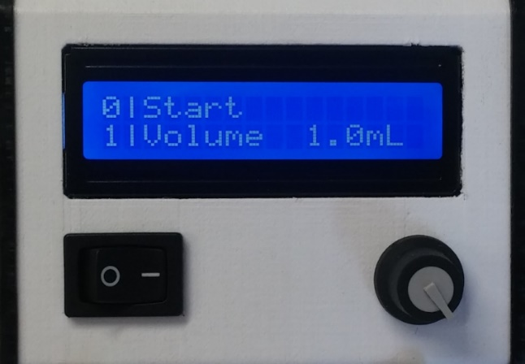
LCD display
power
switch
control knob

User interface of the pump: The menu item “0|Start” is currently selected - pushing the control knob now would initiate pumping.

The user interface provides a comprehensive control of the peristaltic pump. It consists of a LCD display, a control knob and a power switch. The control knob can be turned or pushed.
Turning the knob allows to select from different menu items, the menu item on the upper line is currently selected. Pushing the knob will activate the selected menu item, indicated by a blinking rectangle. The blinking rectangle implies that the menu item is activated.
Once the menu item is activated, it starts depending on the selected item either an action or allows the change of the corresponding value by turning the knob. For all menu items connected to a numerical value the knob can be held to reset the value to zero or double pushed to increase the value by one-tenth of its maximal value. To set the selected value and deactivate a menu item the knob needs to be pushed a second time.
The power switch will immediately shut down the pump and all its components (Arduino, step motor, step motor driver, LCD), except when the pump is connected via USB. The Arduino and the LCD can be powered by USB, so that the power switch will not affect them.
The pumps menu has 10 items, which are listed and described below:
0|Start
Start pumping, the operation mode is depending on the mode selected at “6) Mode”
1|Volume
Set the dosing volume, is only considered if “Dose” is selected at “6) Mode”
2|V.Unit:
Set the volume unit, options are:
“mL”: mL
“uL”: µL
“rot”: rotations (of the pump)
3|Speed
Set the flow rate, is only considered if “Dose” or “Pump” is selected at “6) Mode”
4|S.Unit:
Set the volume unit, options are:
“mL/min”: mL/min
“uL/min”: µL/min
“rpm”: rotations/min
5|Direction:
Choose pumping direction: “CW” for clockwise rotation, “CCW” for counterclockwise
6|Mode:
Set operation mode:
“Dose”: dose the selected volume (1|Volume) at the selected flow rate (3|Speed) when started
“Pump”: pump continuously at the selected flow rate (3|Speed) when started
“Cal.”: Calibration, pump will perform 30 rotations in 30 seconds when started
7|Cal.
Set calibration volume in mL. For calibration, the pump is run once in calibration mode and the resulting calibration volume which was pumped is measured.
8|Save Sett.
Save all settings to Arduinos EEPROM, values are retained during power off and reloaded, when the power is turned on again
9|USB Ctrl
Activate USB Control: Pump reacts to serial commands sent via USB
- Serial interface – remote control via USB
The serial interface is based on the Arduino’s serial communication interface via USB (Baud 9600, 8 data bits, no parity, one stop bit). Any software or programming language capable of writing data to a serial port can be used to communicate with the pump (MATLAB, LabVIEW, Java, python, C#, etc.). All functions of the pump are accessible by sending the corresponding command to the pump, at the end of each command a new line character '\n' (ASCII 10) is required.

Dose: d(volume in µL),(speed in µL/min),(calibration volume in µL)'\n'
e.g.: d1000,2000,1462'\n' (dosing 1mL at 2mL/min, calibration volume = 1.462mL)

Pump: p(speed in µL/min),(calibration volume in µL)'\n'
e.g.: p2000,1462'\n' (pump at 2mL/min, calibration volume = 1.462mL)

Calibrate: c'\n'

Stop: x'\n'
The Arduino environment (Arduino IDE) has a built-in serial monitor, which can read and write serial data, therefore serial commands can be tested without any written code.

- Calibration
Performing a proper calibration before using the pump is crucial for precise dosing and pumping. The calibration will tell the pump how much liquid is moved per rotation, so the pump can calculate how many rotations and which speed is needed to meet the set values. To start the calibration, select the Mode “Cal.” and start pumping or send the calibration command via USB. The standard calibration cycle will perform 30 rotations in 30 seconds. The volume of liquid pumped during this cycle (calibration volume) should be measured precisely. Ensure, that the measurement is not affected by drops sticking to the tubing, the weight of the tubing itself or any other interferences. We recommend using a microgram scale for calibration, as you can easily calculate the volume, if density and weight of the pumped amount of liquid is known. Once you measured the calibration volume you can adjust the pump by setting the value of menu item “7|Cal.” or attaching it to your serial commands.

Please note that any change after calibration to the tubing mount or the pressure difference will affect the precision of the pump. Try to perform the calibration always at the same conditions, at which the pump will be used later. If you remove the tubing and install it again in the pump, the calibration value will change up to 10%, since to small differences in positioning and force applied to the screws. Pulling on the tubing will also change the positioning and therefore the calibration value. If the calibration is performed without pressure difference and the pump is later used to pump liquids at another pressure it will affect precision. Remember even a level difference of one meter can create a pressure difference of 0.1 bar, which will have a slight influence on the calibration value, even if the pump can reach a pressure of at least 1.5 bar using the 0.8 mm tubing.

