Development of a quick and simple DNA extraction method for use with our Shiga-toxin detecting device
In order to use Loop-mediated isothermal amplification (LAMP) as the basis of the detection method of our device, it is necessary to include a DNA extraction step to obtain the template DNA from a sample.
We explored the use of heat lysis with different buffers to obtain template DNA from DH5-alpha competent Escherichia coli previously transformed with pGLO plasmid (BioRad). This extraction method is simple and could potentially be incorporated as an automated step in our device.
We prepared three buffers with varying compositions, adjusting their pH to 8.0:
- Tris-HCl,
- Tris-HCl + EDTA (TE)
- Tris-HCl + EDTA + Triton-X 100 1% + Tween 20 0.5%
We diluted the bacteria culture to an OD600 of 0.6. 20 µl of this solution was mixed with 40 µl of buffer and subjected to 95 °C heating for varying amounts of time ranging from zero to 20 min. Using a NanoDrop™ spectrophotometer (Thermo Scientific), the A260/A280 ratio was measured (Fig 1). According to the manufacturer, a ratio of 1.8 is generally accepted as pure DNA. However, the presence of other cell components present in the sample may alter the results. The trials were ran in duplicates.
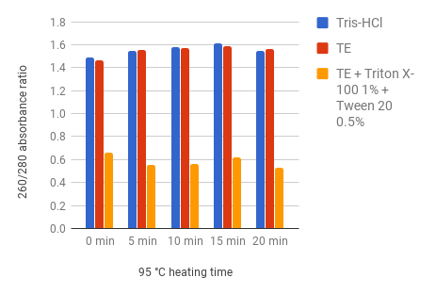
Figure 1. Comparison of the performances of three different buffers. A260/A280 absorbance ratio closer to 1.8 indicates better DNA purity.
Due to the poor results of the buffer containing Triton-X 100 and Tween 20, we discarded this option. Since it is in the important for the user to waste as little time as possible during the food test, we decided to limit the DNA extraction step to 10 min maximum.
The presence of template DNA was corroborated through PCR targeting a sequence in the pGLO plasmid. The PCR products were ran in an agarose gel. We used DH5-Alpha E. coli transformed with BBa_J04450 (backbone: pSB1C3) as negative control and pGLO isolated using the MiniPrep kit (Qiagen) as positive control.
The performances of the Tris-HCl and TE buffers were compared by running PCRs with template obtained through heat lysis at 95 °C for 10 min (Fig 2).
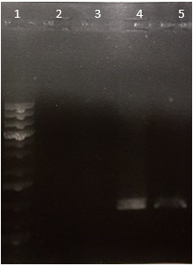
Figure 2. 1) 1 kb+ ladder. 2) Negative control. 3) Tris-HCI treatment. 4) TE treatment. 5) Positive control.
Since the Tris-HCl treatment did not yield template DNA, it was discarded as an option.
Next, we used the agarose gel as a semi-quantitative measure of the PCR output to observe the differences in extraction performance due to varying heating times (Figure 3). We observed that the 10 min treatment had a clearer band compared to the other times. We decided to keep 10 min as our final time for heat lysis.
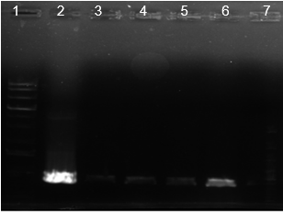
Figure 3. 1) 1 kb+ ladder. 2) Positive control. 3) No-heating treatment. 4) 1 min heating treatment. 5) 5 min heating treatment. 6) 10 min heating treatment. 7) Negative control.
It is still necessary to test this protocol with the LAMP reaction, which requires reagents that were unavailable at the time of these trials.

