# Construction Manual

We have kept the construction manual as simple as possible, so that it can be understood without much previous knowledge about engineering or electronics. Most information is presented graphically rather than relying on long texts.

**Required components & costs**

All required parts are listed in the following table.



Please note that the tubing and straight pins are only available in larger package sizes than needed, you could ask the distributor if they are willing to support your project with free samples. However, many laboratories already have peristaltic pumps and might provide the required tubing.

The screws have standard metric sizes and should be easily found in most workshops at your university. It is not unlikely that you can find the straight pins there as well.

The calculated price of the 3D printed part refers only to the material costs, since we assume, that you have free access to a 3D printer through your university. If you have to use a commercial printing service, the costs will be higher. You can download the 3D models here or at [Thingiverse](https://www.thingiverse.com/thing:2619479).

**3D printing and post processing**

The 3D printed parts have to be cleaned after printing to remove any residues from the printing process. The tools we recommend for postprocessing are a small file and a thread cutter for M3 threads. After the printing process most of the holes have to be widened by using a suitable drill. For the holes that contain M3 screws, a thread has to be cut with the above mentioned thread cutter.

Be careful with removing too much material from the parts in figure on the below, because they are design to have a tight fit and hold the tubing against the needle bearing during the pump process.

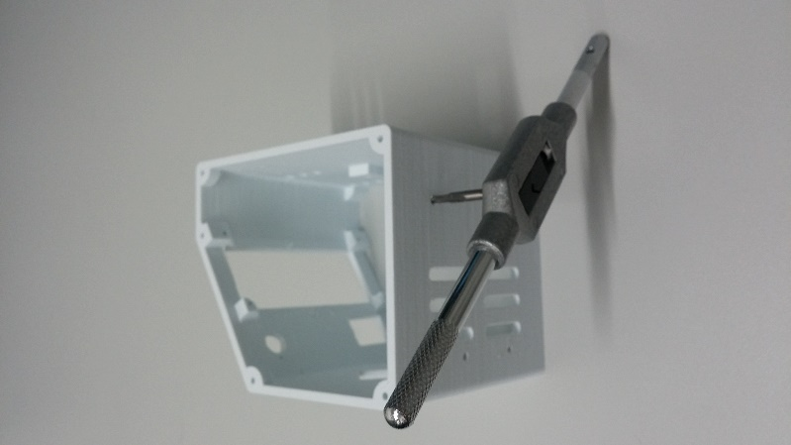 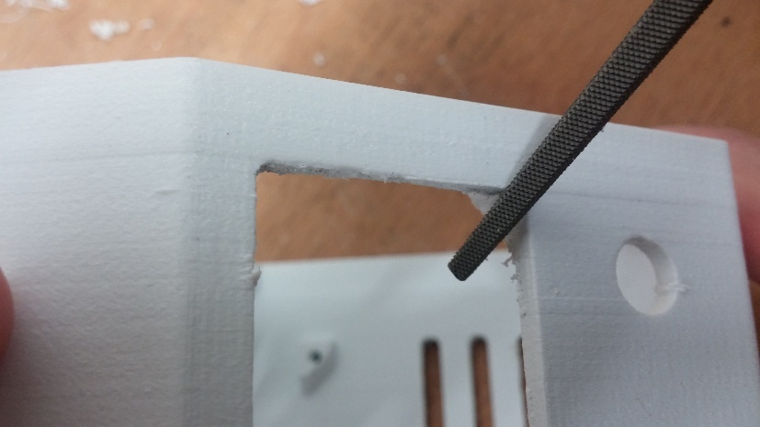

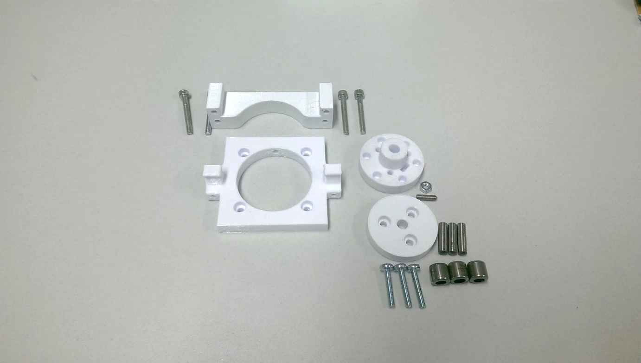

M3, L=25 mm

M3, L=16 mm

M3 nut

M3 grub  
 screw

straight pins

M3, L=25 mm

bearings

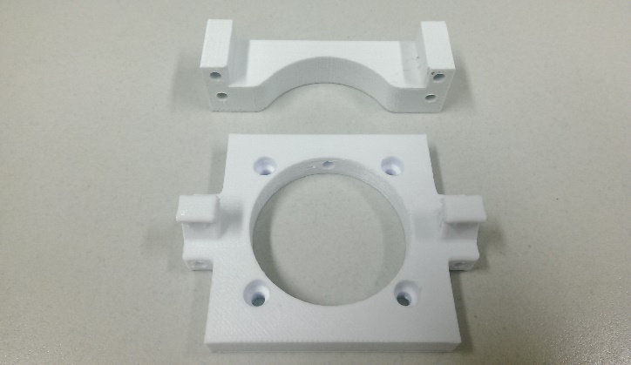

When postprocessing these parts, make sure that no material sticks out on the red marked areas, but that no more than that is removed. These surfaces determine the position of the components to each other and thus the narrow gap with which the tubing is squeezed, so they should be handled carefully.

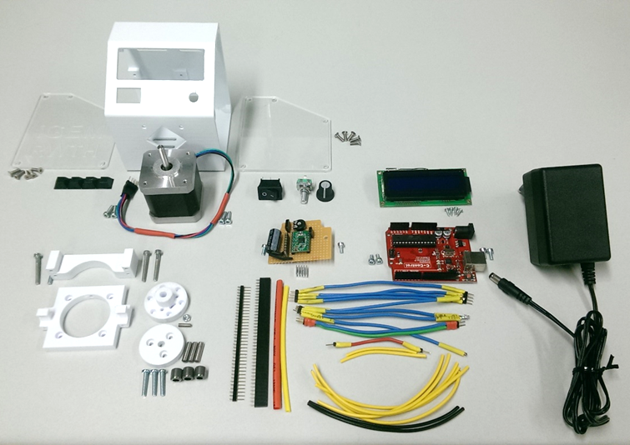

**Cables & Wiring**

The core of the circuit consists of the Arduino and a perfboard. On the perfboard is the stepper motor driver, the trimmer for the LCD, the 47µF capacitor and connections for the power supply of the various components. In order to turn off the Arduino by the power switch, the power supply of the Arduino was interrupted and led to the Perfboard. For this purpose, the diode which is located on the Arduino directly behind the power jack was unsoldered and brought to the perfboard instead.

Section of the Arduino with marked diode

The remaining wiring can be read from the following diagram:

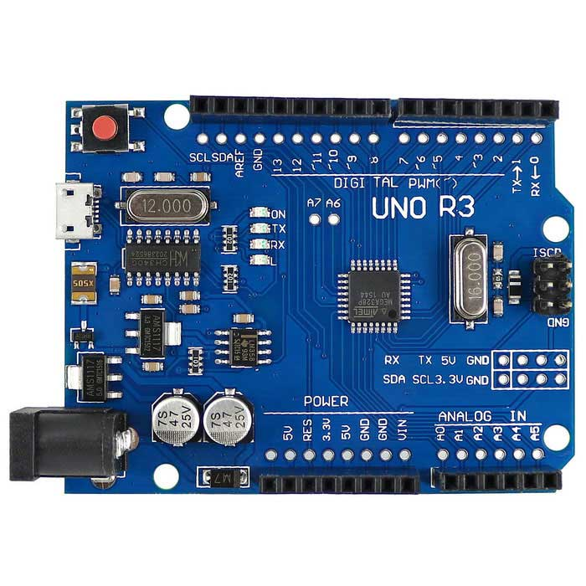

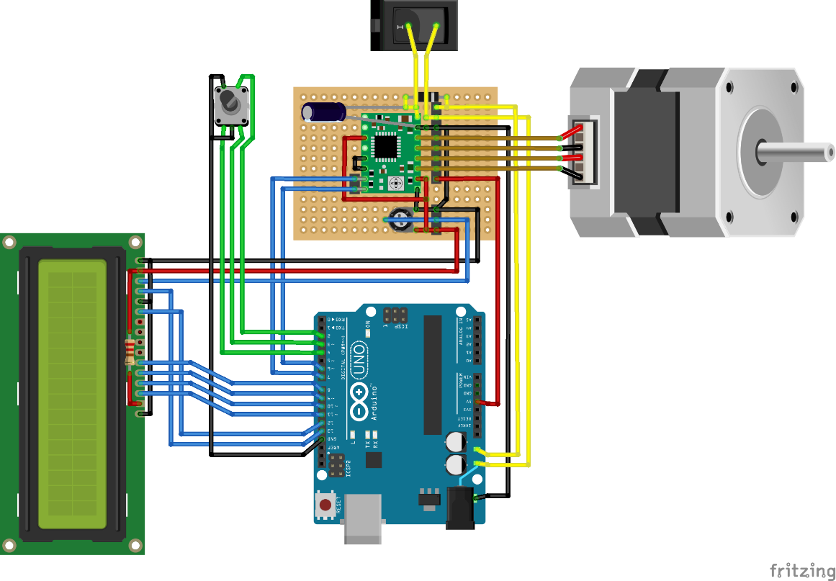

encoder

perfboard

Where the diode was removed,   
connectors were added instead

**Yellow: +12V**

**Red: +5V**

**Black: GND**  
**Green: user input**

**Blue: other data**

capacitor   
47-100 µF

Trimmer 10k Ohm

220 Ohm  
 resistor

A4988 step motor driver

Arduino Uno R3

LCD

step motor

diode from Arduino

power switch

There are three settings that need to be made directly on the circuit. First the current limit for the step motor driver must be set, by adjusting the little screw on the A4988. For example, if the voltage Vref between screw and GND in the on state is 1V, the current limit is twice the value: Imax = 2A (this is the value we used). The higher the current, the higher the torque of the motor, allowing higher speeds and flow rates. However, also the power consumption and the heat development increases.

Furthermore, the mode of the stepper motor can be set via the three pins which are located on the top left of the stepper motor driver (MS1, MS2, MS3). When MS2 is at + 5V, as shown in the wiring diagram, the motor is operated in quarter step mode, which we used.

Pinout of the A4988 step motor driver [1]

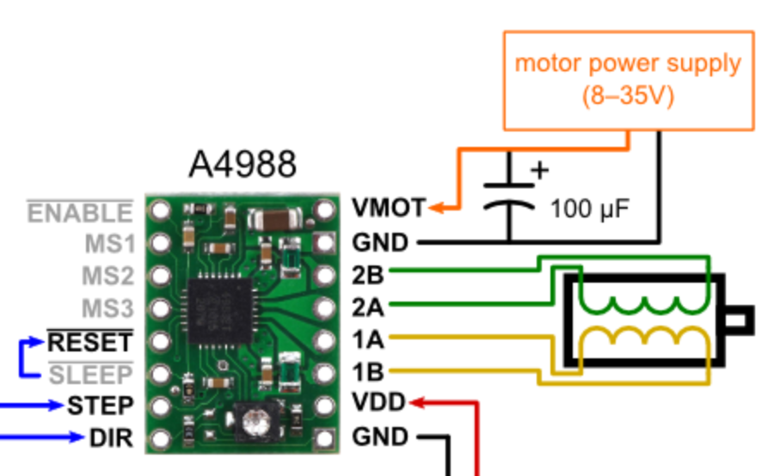

Using this screw, the current limit can be set

This means that exactly one step (1.8 °) is performed for four pulses that the stepper motor driver receives at the STEP pin. As last value to set, the trimmer on the perfboard can be used to adjust the contrast of the LCD.

LCD contrast

Register select (RS)

Enable (E)

Data pin D4

Data pin D5

Data pin D6

Data pin D7

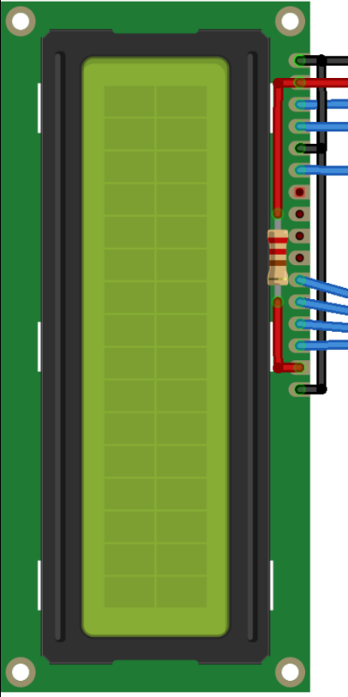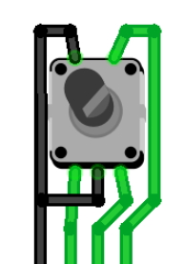

Push button

Phase A

Phase B  
GND

Before mounting it is recommended to test the components and the circuit on a breadboard. On this way, it is easier to find and fix possible mistakes

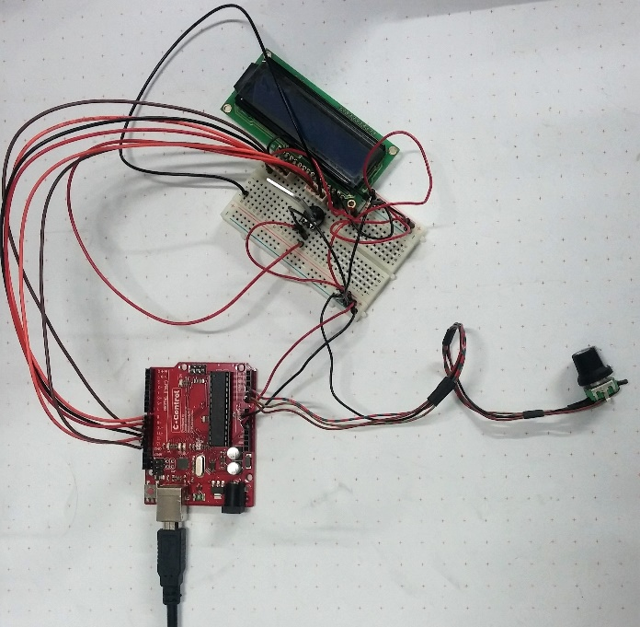

Setup we used to test only LCD and encoder, the menu will work without the step motor.

Unfortunately, the final cabling looks a bit chaotic, so you better stick to the diagrams above.

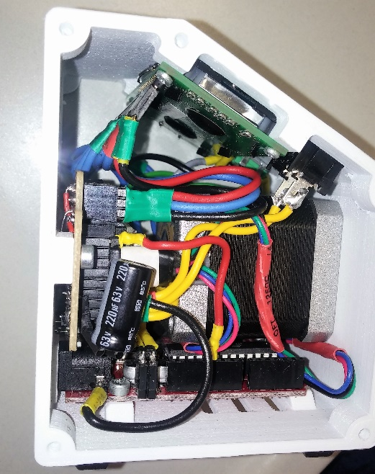 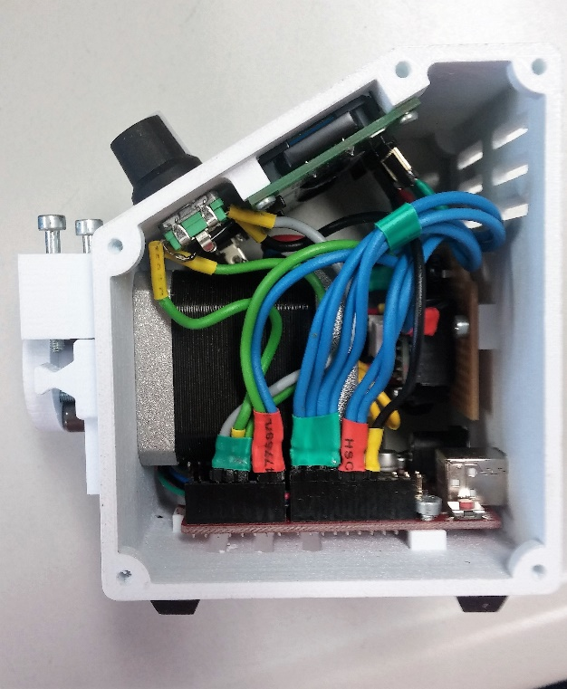

**Assembly**

The video shows the assembly of the components in the intended sequence without the wiring. All connectors should first be attached to the components. The wiring is best done at the point where all the components are inserted, but the side walls have not yet been fixed. The hard to reach screws can be easily reached with a hex-wrench.

1. Insert the power switch and the encoder into their designated hole and fix them to the case. Attach the control knob to the encoder – be careful – once you attached the knob, it might destroy the encoder if you try to remove it again.
2. Attach the LCD display with small tapping screws, make sure to solder the resistor and wiring to the display before assembly.
3. Fix the Arduino Uno board to the case using 8 mm M3 screws.
4. Insert the step motor and attach it to the case together with the 3D printed part (Pump_case_bottom) using four 10 mm M3 screws.
5. Attach the perfboard to the case – make sure you soldered all components to the perfboard as shown in the wiring diagram.
6. Wire the electronic parts inside the case.
7. Close the case by adding the side panels using 10x 8 mm M3 screws.
8. Assemble the bearing mount as shown in the video and attach it to the motor’s shaft using a 3 mm grub screw
9. Finally, attach the counter support for holding the tube (Pump_case_top_120°) with two 25 mm M3 screws and insert the tubing. Insert two 25 mm M3 screws to keep the tubing in place during the pump process

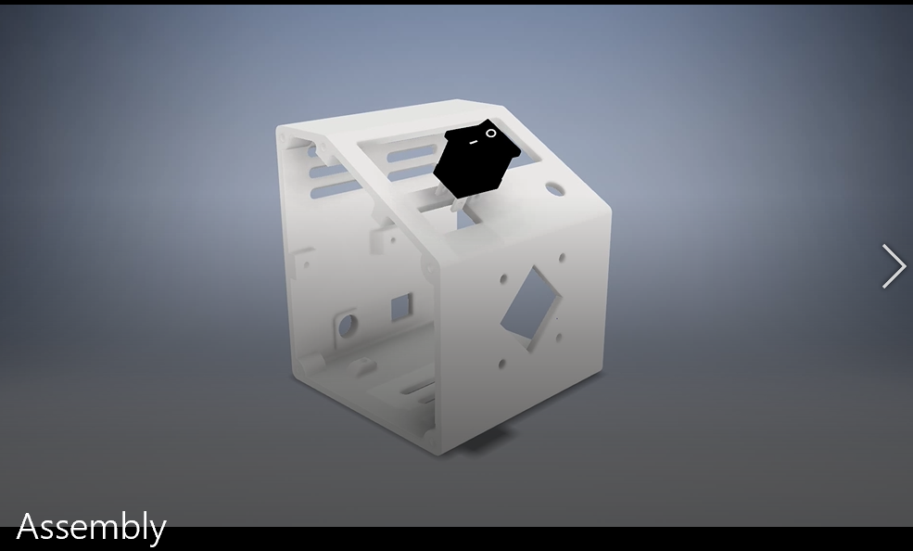 [(Video)](Assembly_m4v.mp4)

**Files**

CAD models of alle 3D printed parts: “Peristaltic Pump – CAD.zip”

Arduino Software: „Arduino Software Peristialtic Pump.zip”

Wiring diagram: “Open Peristaltic Pump Wiring Fritzing.zip”

**DIY and Open Source platforms**

Visit our project and share you experiences and improvements on Thingiverse, GitHub and Instructables!

Thingiverse: Repository for 3D printable parts and models

<https://www.thingiverse.com/thing:2619479>

GitHub: Hosting sourcecode files and offering version control

<https://github.com/iGEM-Aachen/Open-Source-Peristaltic-Pump>

Instructables: Publishing DIY projects and step-by-step instructions

<http://www.instructables.com/id/Open-Source-Peristaltic-Pump/>

**References**  
[1] <https://www.pololu.com/product/1182>