Part 1 Comprehensive Analysis
For the question no. 3 and 4, over 80% interviewees (83.3%) have heard of genetic engineering, while only 54.5% interviewees heard of synthetic biology, revealing that the promotion of synthetic biology is insufficient that people are not familiar with it.

For the second part, which tests for the interviewees’ understandings on synthetic biology, most people get correct answer on the question asking whether GM food and medicine production by using engineered bacteria are synthetic biology, which are 89.4% and 84.8% respectively. However, for the another two questions, whether using engineered bacteria to convert toxic gases on Mars into non-harmful gases and stem cell therapy are kinds of synthetic biology, the correct ratios are obviously dropped, especially the latter: only 30.3% interviewees know that stem cell therapy is not an example of synthetic biology, while only 59.1% interviewees agree that detoxifying the harmful gases in Mars by engineered bacteria is synthetic biology, which is a real Igem iGEM project. These figures display that most people correlate synthetic biology with medical applications, but actually not all medical applications are examples of synthetic biology, eg stem cell therapy. More education and promotion of synthetic biology may be needed.

For the third part, which is asking interviewees’ acceptance on various applications, all 4 questions get a quite high acceptance (the 4 questions are the same as the second part), except that detoxifying the harmful gases in Mars get a bit lower acceptance compared to another 3 questions, which is 75.8%. For the forth part, which concerns interviewees’ feeling towards synthetic biology/ genetic engineering as well as their viewpoints on whether synthetic biology is beneficial to human, majority shows positive attitudes on these two questions. High acceptance of synthetic biology and positive attitudes on these two parts may be related to the facts that most interviewees are teenagers and have received tertiary education.

Eventually, for the last part, which focus on our project: inquiring whether they will adopt regular check-up if there is a saliva-based test paper for diagnosis. The result shows positive feedback: 78.8% interviewee will probably adopt regular bogy check, and even 30.3% people say they will absolutely have a regular body check.

Part 2 Statistical analysis
In order to see the effect of study biology on the attitudes on different questions, we compare the results of both have and haven’t studied biology in high school by statistical proof. Question 4-7, 9 have undergone statistical analysis [Fisher Exact Test, 2-sample t-test and 2-sample Z-test for binomial proportion are used, α (significance level) = 0.05]. Complete statistical proof is listed below as attachment 2.

Almost all questions aren’t statistically significant, in other words, there is not a great difference between have and haven’t studied biology group, except question no.7, H₀ is rejected, revealing studying biology group is more likely to agree that synthetic biology is beneficial to human, compared to haven’t studied biology group. We can conclude that study biology can help change people’s mindset, turning their perspective towards biology into positive way.

Attachment 2 Data of Comprehensive Analysis
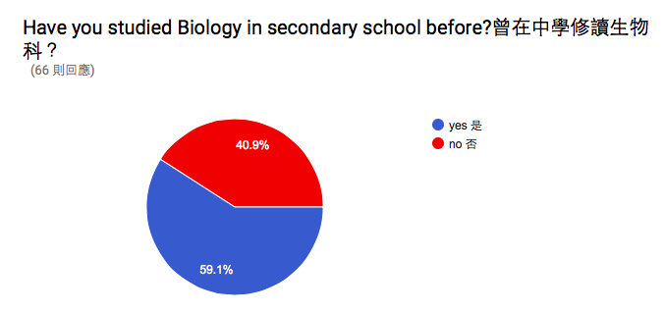
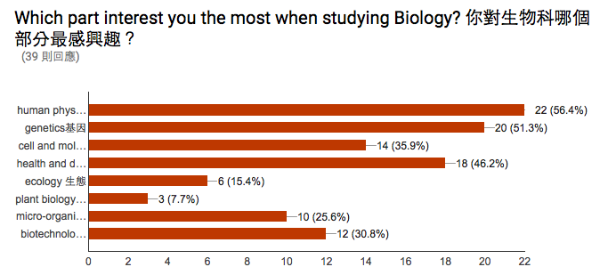
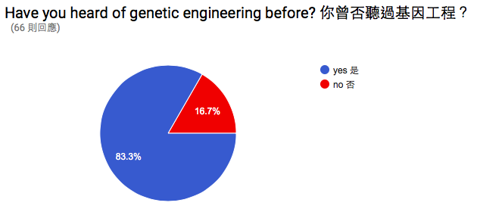
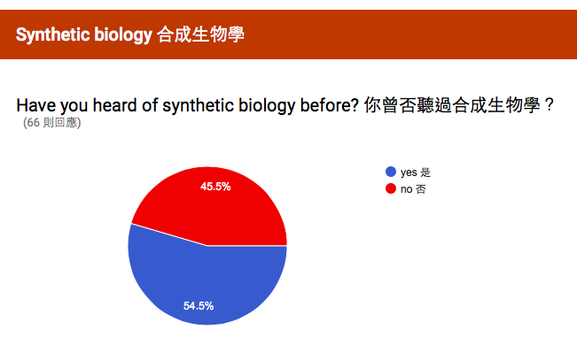
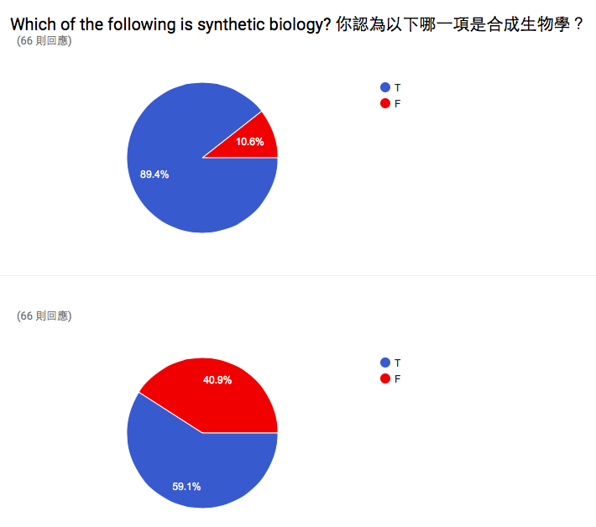
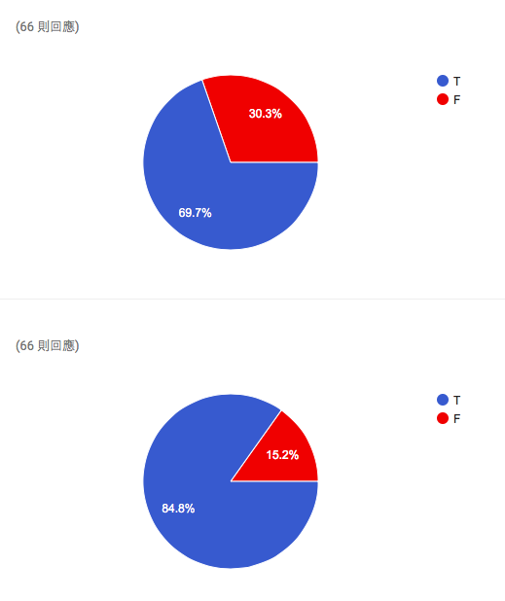
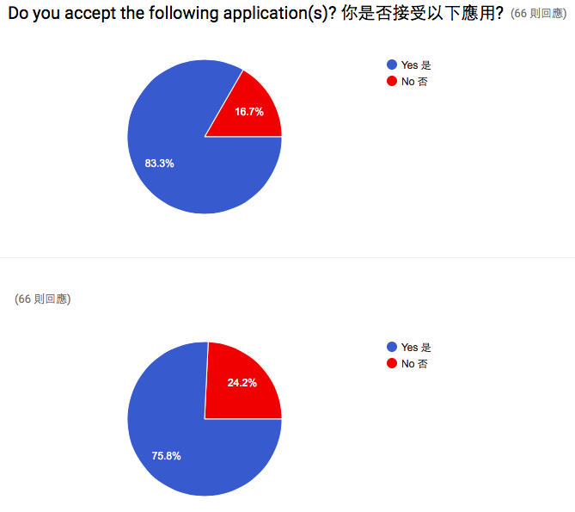
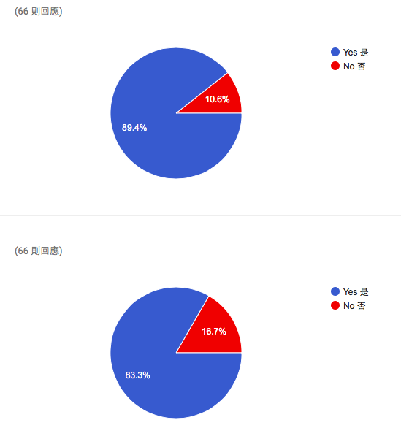
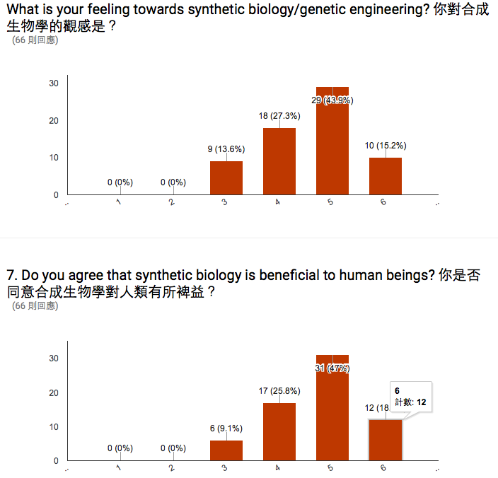
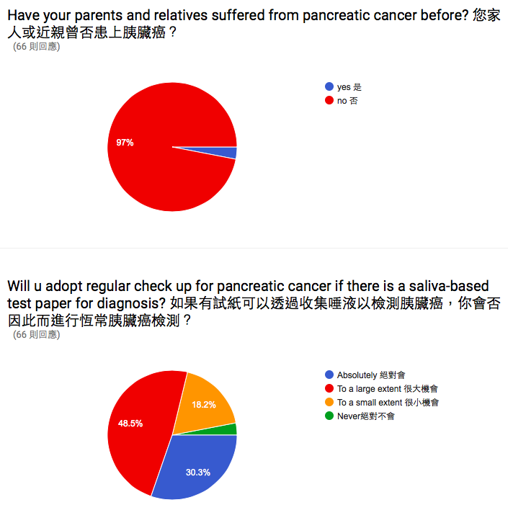

Attachment 2 Statistical analysis
4. Have you heard of synthetic biology before? 你曾否聽過合成生物學？
Yes: p^1=0.641025641
No: p^₂= 0.4074074074

H₀: p1= p2 H₁: p1 ≠p2
α = 0.05

n₁p^₁(1−p^₁) = 8.974358975 >5
n₂p^₂(1−p^₂) = 6.518518518 >5
p^= (n₁ p^1+ n₂p^₂)/ (n₁+n₂) = 0.545454545

continuity correction is an adjustment that is made when a discrete distribution is approximated by a continuous distribution.

Z= [(p^₁- p^₂)- (1/(2n₁)+1/(2n₂))] / $\sqrt[2]{p^q^(\frac{1}{n1}+\frac{1}{n2})}$ = 1.6225

Z_{0.975}= 1.96 > 1.6225
So, we don’t reject H₀

5. Which of the following is synthetic biology? 你認為以下哪一項是合成生物學？
a) Yes: p^1= 0.9487179487
No: p^₂= 0.8148148148

H₀: p1= p2 H₁: p1 ≠p2
α = 0.05

n₁p^₁(1−p^₁) = 1.897435898 < 5
n₂p^₂(1−p^₂) = 4.074074074 < 5
We should apply Fisher Exact Test then.
The Fisher exact test statistic value is 0.112526. The result is not significant at p < .05.

b) Yes: p^1= 0.333333333
No: p^₂= 0.259259259
H₀: p1= p2 H₁: p1 ≠p2
α = 0.05

n₁p^₁(1−p^₁) = 8.666666666 >5
n₂p^₂(1−p^₂) = 5.185185186 >5
p^= (n₁ p^1+ n₂p^₂)/ (n₁+n₂) = 0.303024545

continuity correction is an adjustment that is made when a discrete distribution is approximated by a continuous distribution.

Z= [(p^₁- p^₂)- (1/(2n₁)+1/(2n₂))] / $\sqrt[2]{p^q^(\frac{1}{n1}+\frac{1}{n2})}$ = 1.7593

Z_{0.975}= 1.96 > 1.7593
So, we don’t reject H₀

c) Yes: p^1= 0.692307692
No: p^₂= 0.4444
H₀: p1= p2 H₁: p1 ≠p2
α = 0.05

n₁p^₁(1−p^₁) = 8.307692308 >5
n₂p^₂(1−p^₂) = 6.66653328 >5
p^= (n₁ p^1+ n₂p^₂)/ (n₁+n₂) = 0.590890909

continuity correction is an adjustment that is made when a discrete distribution is approximated by a continuous distribution.

Z= [(p^₁- p^₂)- (1/(2n₁)+1/(2n₂))] / $\sqrt[2]{p^q^(\frac{1}{n1}+\frac{1}{n2})}$ = 0.371404766

Z_{0.975}= 1.96 > 0.371404766
So, we don’t reject H₀

d) Yes: p^1= 0.8974358974
No: p^₂= 0.7777777778

H₀: p1= p2 H₁: p1 ≠p2
α = 0.05

n₁p^₁(1−p^₁) = 1.897435898 < 5
n₂p^₂(1−p^₂) = 4.074074074 < 5
We should apply Fisher Exact Test then.
The Fisher exact test statistic value is 0.112526. The result is not significant at p < .05.

5. Do you accept the following application(s)? 你是否接受以下應用?
a) Genetically-modified food 基因改造食物
Yes: p^1= 0.84615385
No: p^₂= 0.82142857

H₀: p1= p2 H₁: p1 ≠p2
α = 0.05

n₁p^₁(1−p^₁) = 5.07837681 > 5
n₂p^₂(1−p^₂) = 3.96095508 < 5
We should apply Fisher Exact Test then.

The Fisher exact test statistic value is 0.748683. The result is not significant at p < .05.
b) Use engineered bacteria to convert toxic gases on Mars into non-harmful gases 利用基因改造細菌淨化火星上的有毒氣體
Yes: p^1= 0.82051282
No: p^₂= 0.67857143

H₀: p1= p2 H₁: p1 ≠p2
α = 0.05

n₁p^₁(1−p^₁) = 5.74391025 > 5
n₂p^₂(1−p^₂) = 5.88971925 > 5
p^= (n₁ p^1+ n₂p^₂)/ (n₁+n₂) = 0.762445887

continuity correction is an adjustment that is made when a discrete distribution is approximated by a continuous distribution.

Z= [(p^₁- p^₂)- (1/(2n₁)+1/(2n₂))] / $\sqrt[2]{p^q^(\frac{1}{n1}+\frac{1}{n2})}$ = 1.0381

Z_{0.975}= 1.96 > 1.0381
So, we don’t reject H₀

c) Stem cell therapy 幹細胞治療
Yes: p^1= 0.94871795
No: p^₂= 0.82142857

H₀: p1= p2 H₁: p1 ≠p2
α = 0.05

n₁p^₁(1−p^₁) = 1.89806409 < 5
n₂p^₂(1−p^₂) = 3.96095508 < 5
We should apply Fisher Exact Test then.

The Fisher exact test statistic value is 0.112526. The result is not significant at p < .05.

d) Use bacteria to produce medicine利用基因改造細菌製造藥物
Yes: p^1= 0.8717948718
No: p^₂= 0.7777777778

H₀: p1= p2 H₁: p1 ≠p2
α = 0.05

n₁p^₁(1−p^₁) = 4.35832566< 5
n₂p^₂(1−p^₂) = 4.66657333 < 5
We should apply Fisher Exact Test then.
The Fisher exact test statistic value is 0.335913. The result is not significant at p < .05.

6. What is your feeling towards synthetic biology/genetic engineering? 你對合成生物學的觀感是？
no= 27
mean = 4.4444
sd= 0.97402
var = 0.94872
yes
n= 39
mean = 4.71795
sd= 0.85682
var = 0.73414

H₀: μ1= μ2 H₁: μ1 ≠μ2
α = 0.05
Firstly, test the equality of the variances
H₀: σ0= σ1 H₁: σ0 ≠ σ1

F = S²₁/S²₂
= 0.73414/ 0.94872
= 0.7738

F_{39, 27, 0.975} = 2.07 > 0.7738
So, we don’t reject H₀

We adopt 2-sample t- test with equal and unknown variance

S²_{p}= 􏰀[(n1−1)s²₁+(n2−1)s²₂]/ (n1 + n2 -2)
= 0.8510

t= [(x1-x2)-0] / $\sqrt[2]{S2p (\frac{1}{n1}+\frac{1}{n2})}$
=0.5692
P-value= 2*(1-0.7144)= 0.5652 >0.05

We don’t reject H₀. So, the mean of the feeling towards synthetic biology/genetic engineering of studying biology group is not statistically different to that of haven’t studied biology group.

7. Do you agree that synthetic biology is beneficial to human beings?
你是否同意合成生物學對人類有所裨益？
yes
n= 39
mean = 4.92308
sd= 0.7393
var = 0.54656

no
n= 27
mean = 4.48148
sd= 0.97548
var = 0.95157
H₀: μ1= μ2 H₁: μ1≠μ2
α = 0.05
Firstly, test the equality of the variances
H₀: σ0= σ1 H₁: σ0 ≠ σ1

F = S²₁/S²₂
= 0.54656/ 0.95157
= 0.5743

F_{39, 27, 0.975} = 2.07 > 0.5743
We don’t reject H₀.

We adopt 2-sample t- test with equal and unknown variance

S²_{p}= 􏰀[(n1−1)s²₁+(n2−1)s²₂]/ (n1 + n2 -2)
= 0.711095313

t= [(x1-x2)-0] / $\sqrt[2]{S2p (\frac{1}{n1}+\frac{1}{n2})}$
=2.091738426
P-value= (1-0.7144)*2 = 0.0404<0.05

We reject H₀. So, the mean of agreeing synthetic biology is positive of studying biology group is statistically different to that of haven’t studied biology group. We can conclude that study biology can help change people’s mindset, turning their perspective towards biology into positive way.

So, the mean of agreeing synthetic biology is positive of studying biology group is statistically different to that of haven’t studied biology group.

8. Will u adopt regular check up for pancreatic cancer if there is a saliva-based test paper for diagnosis? 如果有試紙可以透過收集唾液以檢測胰臟癌，你會否因此而進行恆常胰臟癌檢測？
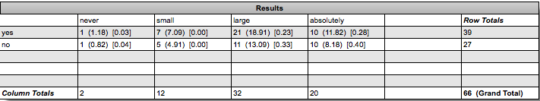
The contingency table above provides the following information: the observed cell totals, (the expected cell totals) and [the chi-square statistic for each cell].

The chi-square statistic is 1.3202. The p-value is .724352. The result is not significant at p < .05.

