You will receive 6 samples; 3 samples contain RFP under the control of a strong promoter, 3 constructs have RFP under the control of a weak promoter. Each sample has been stored under different conditions (room temperature, 4 °C, -80 °C).
Filter Settings:
RFP
Excitation – 584nm
Emission – 607nm
Path length correction should be off.
OD600
Use instrument’s regular OD600 protocol.
Notes:
All procedures should be performed under sterile conditions.
Specimens are Erythromycin (Erm) resistant, LB media requires an Erm concentration of 500µg/ml.
Reviving Freeze Dried Bacteria:
- Warm 500µl of SOC medium per sample (6 in total) to 37°C ( ̴15 mins in an incubator).
- Revive each freeze dried sample by resuspending the “powder” in 400µl of prewarmed SOC.
- Inoculate the full 400µl in 10ml liquid media of LB – Erm (500µg/ml) in a 50 ml falcon tube.
- Make up 10ml LB-Erm as a control (blank).
- Cover tubes with aluminium foil to block light.
- Take sample for T0.
- Incubate at 37°C and 220 rpm.
Sampling:
- Take 500µl samples at 0, 1, 2, 4, and 6 hours and measure fluorescence at each time point. Place the samples on ice during processing.
- Pipette 100 µl per sample into each well, with three technical replicates per sample.
- Depending on the OD600, samples should be diluted to be in the detection range of the machine (usually the detection range is between 0 and 1).
- For each time point, at least 3 wells should contain 100 ul of the blank solution made up previously (step 4, see above).
- RFP and OD600 should be measured at each timepoint.
- Import Raw data to Excel Spreadsheet and please send them to team UNOTT :D
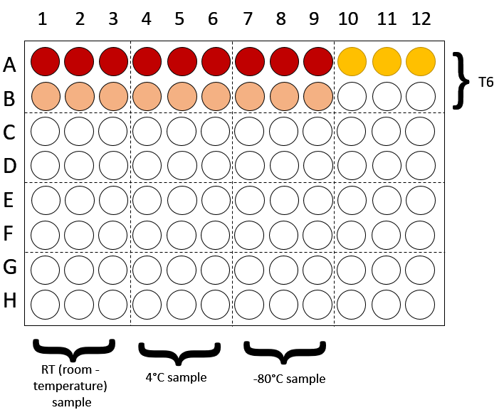
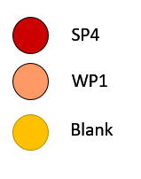
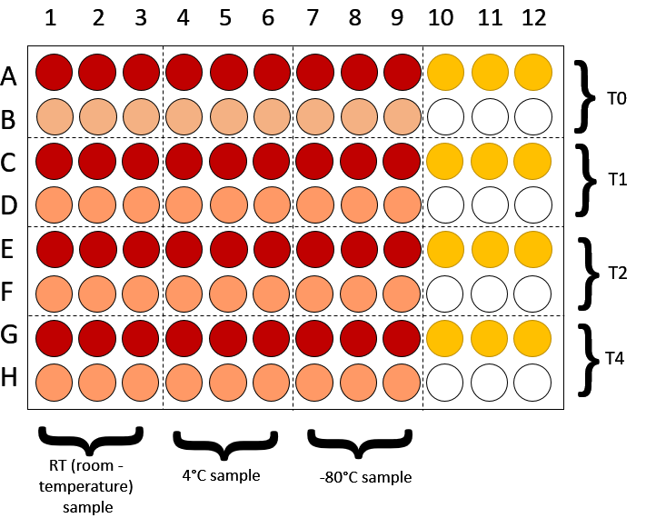
Example Plate:

